COMMUNITY

Creamy Broccoli & Cauliflower Soup (Only 60 Calories)
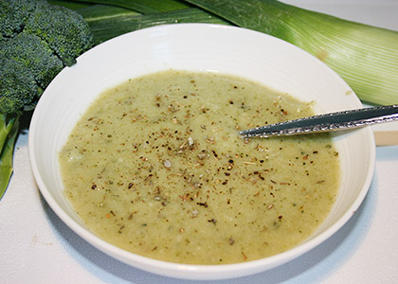
By: Claire Georgiou, Reboot Naturopath, B.HSc ND
Who needs heavy cream when you can make a creamy soup right out from veggies? This is an easy, vegan, delicious soup that you can enjoy anytime. You can swap this soup in place of any of the green vegetable meal recipes. Feel free to put your own spin on it by spicing it up with your favorite herbs.

INGREDIENTS:
- 0live oil or coconut oil to saute vegetables
- 1 leek, sliced
- 1 brown onion, chopped
- 4 fresh garlic cloves, crushed
- 1 broccoli head, chopped coarsely
- 1 large zucchini (courgette), chopped coarsely
- 1 cauliflower head, chopped coarsely
- 6 cups (1.5 L) vegetable broth or stock
- salt and pepper, to taste
- 1 tsp dried turmeric (optional)
- 1 tsp dried chili (optional)

DIRECTIONS:
- Wash and prepare, chop and slice vegetables.
- Heat oil in large pot and sauté vegetables over a low to medium heat the leeks, onions and garlic until translucent.
- Add in the broccoli, zucchini and cauliflower and stir for a few minutes.
- Add the remaining ingredients and bring to the boil then turn down the heat and simmer for 10-15 minutes or until the vegetables are soft.
- Once cooked, use a stick blender and blend the soup to form a smoother texture or leave a little chunky. You can also use a normal blender or chop vegetables into bite size pieces and leave super chunky.
- Add in any fresh herbs for garnish (optional) and serve immediately.Note: This soup will freeze easily and will store in the fridge for up to 3 days.

SUBSTITUTIONS:
- Leek – scallions, spring onion
- Broccoli – brussels sprouts, kale, spinach
- Zucchini – celery, celeriac root
- Cauliflower – potato, sweet potato
Prep time: 20 minutes
Cook time: 15 minutes
Total time: 35 minutes
Servings: 6 -

